Operating System Review Problems
- What is a process？ Please draw a process state transition diagram with nine states in Unix SVR4?
- Illustrated some scenarios where process switch occur?
- Suppose there are three processes running in an operating system with multithreading as following:
Process ID | Threads
A | T11, T12
B | T21, T22
C | T31, T32
If the multithreading is supported by user-level implementation and thread T11 is blocked, which thread may be scheduled to run next? If the multithreading is supported by kernel-level implementation, which thread may be scheduled to run next?
- What is race condition? Give a program implementation to demonstrate the mutual exclusion enforced by Test and Set (or exchange) instruction or by semaphore?
- Consider the following program:
boolean blocked[2];
int turn;
void P(int id)
{
while (true) {
blocked[id] = true;
while (turn != id){
while (blocked[1-id]) /* do nothing */;
turn = id;
}
/* critical section */
blocked[id] = false;
/* remainder */
}
}
void main()
{
blocked[0] = false;
blocked[1] = false;
turn = 0;
parbegin(P(0), P(1));
}
This software segment is the solution to the mutual exclusion problem for two processes. Find a counterexample(反例) that demonstrates that this solution is incorrect.
考虑进程0执行到blocked[id] = true这个语句是发生了进程切换，操作系统调度进程1运行。这种情况下会导致进程0和进程1同时进入临界区。
- Give a solution to bounded producer-consumer problem with semaphore.
- What is deadlock?
- Banker algorithms? Safe state/unsafe state
- Address mapping in paging system:
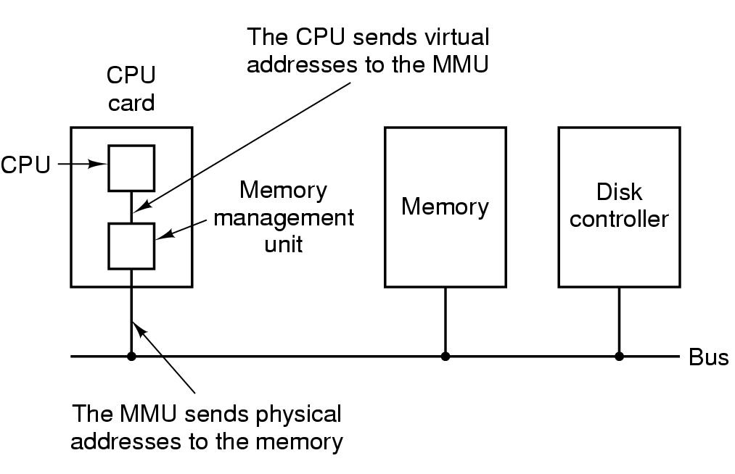
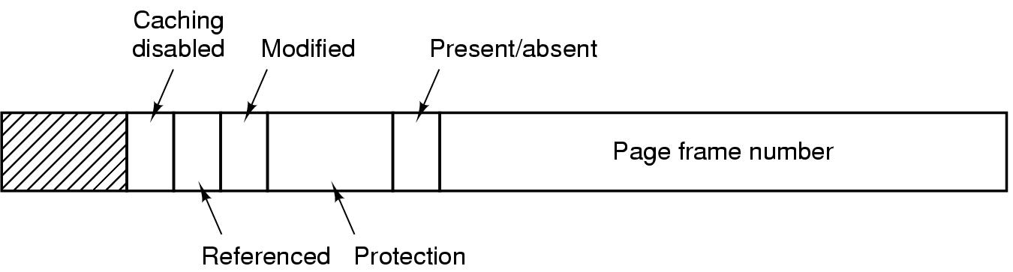
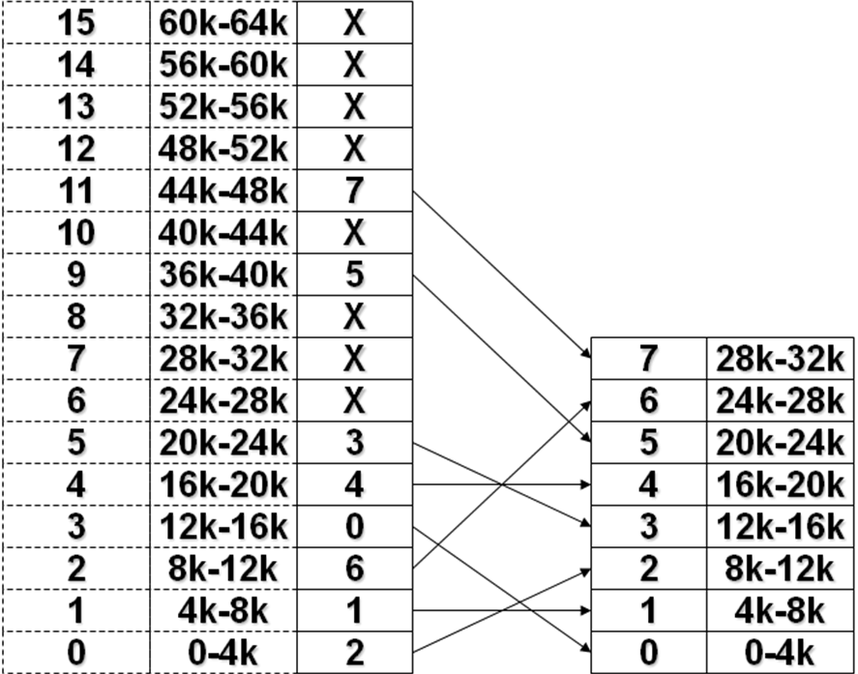
- What is TLB?
- Page replacement algorithms (Optimal/LRU/FIFO/CLOCK) in paging system.
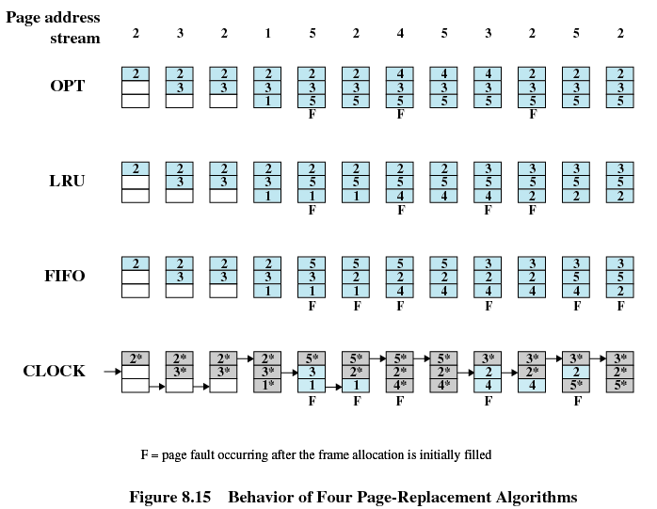
LRU:
- Replaces the page that has not been referenced for the longest time
- By the principle of locality, this should be the page least likely to be referenced in the near future
- Each page could be tagged with the time of last reference. This would require a great deal of overhead
CLOCK:
- Additional bit called a use bit
- When a page is first loaded in memory, the use bit is set to 1
- When the page is referenced, the use bit is set to 1
- When it is time to replace a page, the first frame encountered with the use bit set to 0 is replaced.
- During the search for replacement, each use bit set to 1 is changed to 0
- What is preemptive or nonpreemptive scheduling decision mode? How to compute turnaround time in different short-term scheduling algorithms?
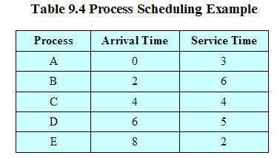

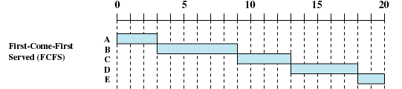

- Why Disk cache is usually used in operating system?
- Disk arm scheduling algorithms
- What is Absolute path or relative path? Explain how file pathname /usr/ast/mbox is be parsed in Unix SVR4?
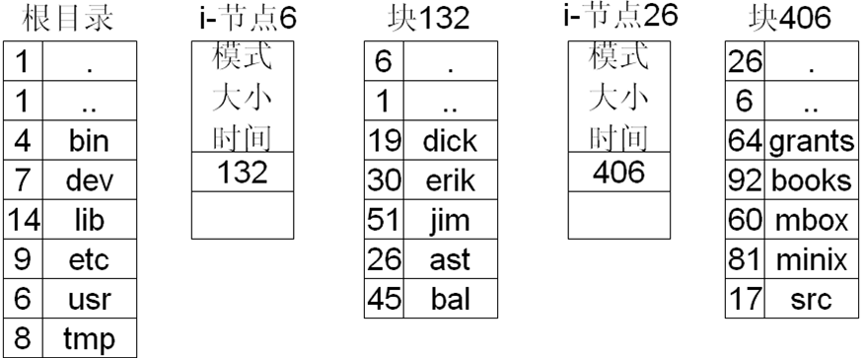
- Consider a UNIX-style i-node with 10 direct pointers, one single-indirect pointer, and one double-indirect pointer. Assume that the disk block size is 1 Kbytes, and that the size of a disk block address is 4 bytes. How large a file can be indexed using such an i-node?
